Ex.No:8
Date: Testing of Requirements

Aim:
The aim of this experiment is to estimate the test coverage metrics and evaluate the structural complexity of a given program using its Control Flow Graph (CFG). This involves identifying nodes, edges, and independent paths in the program and calculating Cyclomatic Complexity to determine the minimum number of test cases required for effective testing. The experiment also helps in understanding how the program structure influences testing efficiency and software quality.
Problem Description:
In software testing, it is important to ensure that all parts of a program are executed and validated properly. The given problem focuses on analyzing a program by converting it into a control flow graph, where each statement or block is represented as a node, and the flow of execution is represented as edges. By analyzing this graph, we can determine the complexity of the program and identify the number of independent execution paths. This helps testers design test cases that achieve maximum coverage and detect logical errors effectively.
Given Conditions / Constraints:
The given program consists of sequential statements, decision-making constructs (like if/else), and looping structures. The program is assumed to have a single entry and single exit point. Each block of code is treated as a node, and the control flow between statements is represented as edges. The values required for computation include the number of nodes (N), number of edges (E), and number of predicate nodes (P). These values are used to calculate Cyclomatic Complexity and test coverage metrics.
Approach / Methodology:
The methodology followed in this experiment involves first analyzing the given program and dividing it into logical blocks. Each block is represented as a node in the control flow graph. Next, edges are drawn between nodes to represent the flow of control. After constructing the CFG, the total number of nodes and edges are counted. Cyclomatic Complexity is then calculated using the standard formulas: V(G) = E – N + 2 or V(G) = P + 1
Finally, the number of independent paths is identified, and test cases are designed to cover all paths, ensuring complete path coverage.
Planning and Estimation:
The experiment is planned by systematically breaking down the program into smaller logical blocks (nodes) and mapping the control flow as edges. Estimation includes counting the total number of nodes (N), edges (E), and predicate nodes (P). Based on these values, Cyclomatic Complexity is estimated, which directly gives the minimum number of test cases required. This planning helps in estimating the testing effort and resources needed to achieve full path coverage.
Scheduling / Design Considerations:
The design of the Control Flow Graph (CFG) is done by representing each logical block of code as a node and drawing directed edges to show the execution flow. Decision nodes (predicate nodes) are clearly identified for branching conditions and loops. The node diagram is carefully constructed to visualize all possible execution paths. Proper scheduling ensures that the CFG is drawn accurately, complexity is calculated correctly, and test cases are designed for each independent path. Care is taken to maintain a single entry and single exit point in the graph.
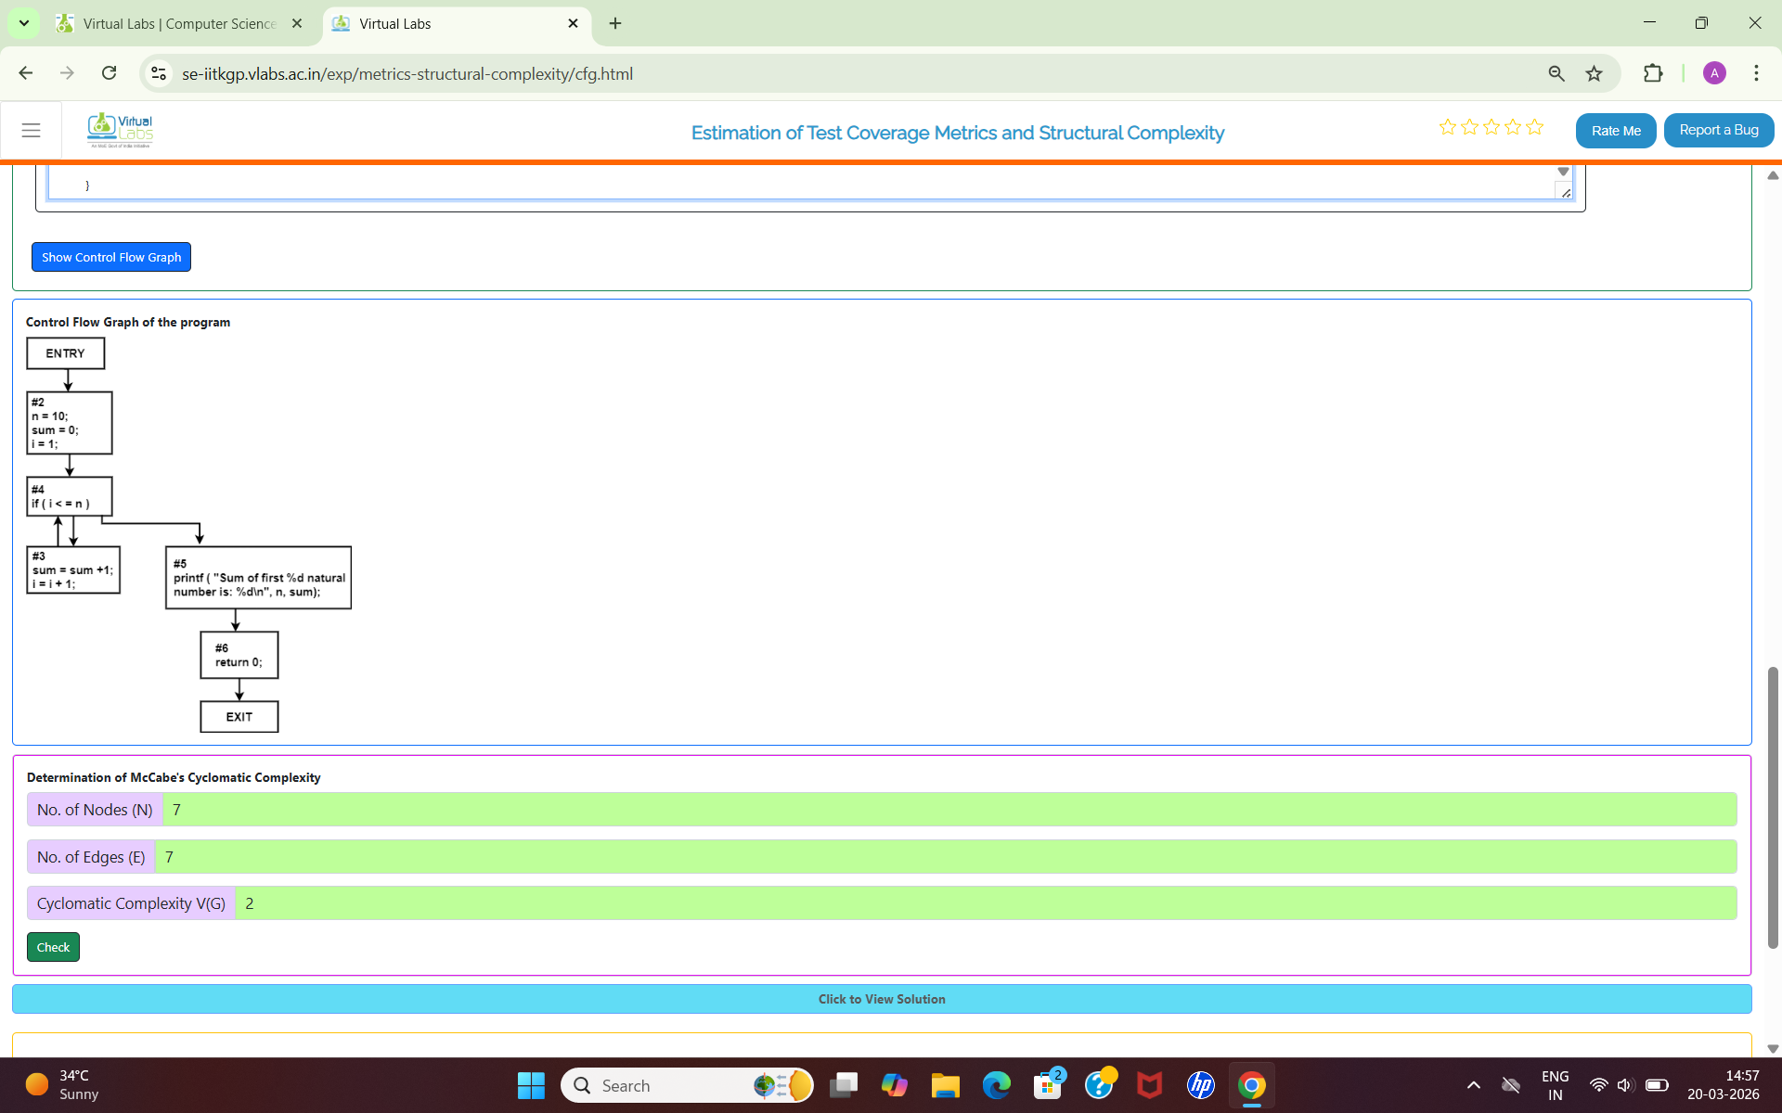
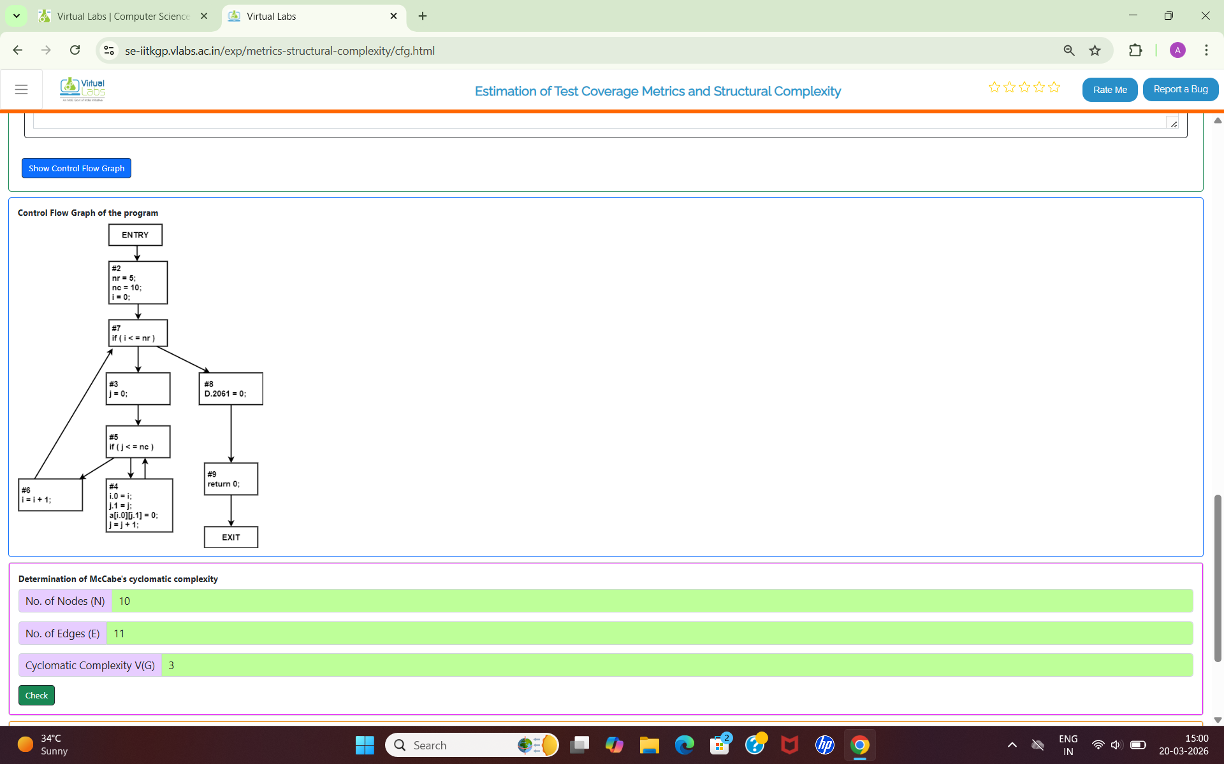
Feasibility Analysis:
Constructing a Control Flow Graph and calculating Cyclomatic Complexity is a highly feasible and standard white-box testing technique. It is practical for programs with sequential, decision, and looping constructs. This method is efficient because it provides a clear quantitative measure of program complexity and directly indicates the minimum number of test cases needed. The approach is manageable within a laboratory session and significantly improves the quality of testing by ensuring all independent paths are covered.
Result:
From the constructed control flow graph, the number of nodes and edges are identified, and Cyclomatic Complexity is calculated. For example, if the number of nodes is 10 and the number of edges is 11, then using the formula V(G) = E – N + 2, the Cyclomatic Complexity is 3. This indicates that there are 3 independent paths in the program. Therefore, at least 3 test cases are required to achieve complete path coverage. The result confirms that the complexity of the program is moderate and manageable for testing.
Conclusion:
The experiment successfully demonstrates how to estimate test coverage metrics and analyze structural complexity using a control flow graph. By calculating Cyclomatic Complexity, we can determine the minimum number of test cases required for effective testing. This method improves software quality by ensuring that all independent paths are tested. It also helps developers understand program structure, reduce errors, and optimize code design. Thus, CFG and Cyclomatic Complexity are essential tools in software testing and quality assurance.

